How to update the firmware on your device.
- Before firmware update procedure do not forget to backup your data
- All data in the device will be removed
- Firstly, turn your MIRA device in UPDATE mode. Press F4 button, and while you hold it, press ON/OFF button once. Do not release F4 button until the special image appears on the screen.
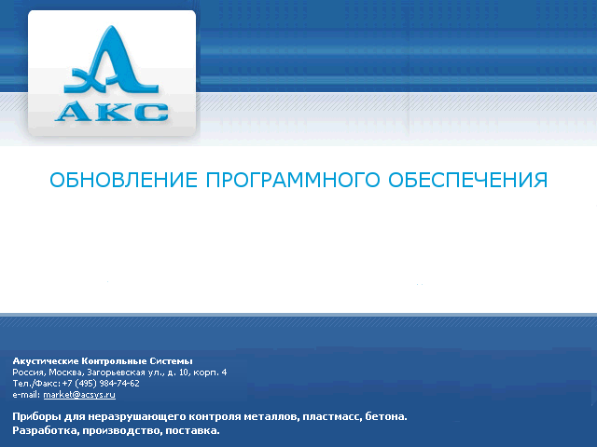

- Connect your MIRA device to a PC. During Hardware Wizard choose the driver manually. (linux.inf – Windows XP, Vista / linux7.inf –Windows 7)

- Then, open Update program, select firmware file from the directory - A1040_v3.2-8.x.15.fs using Load button.
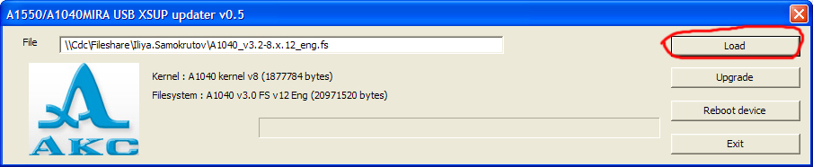

- After you have chosen the file, press Upgrade and reboot button. Wait for about 7-10 minutes, until Update process will be finished. Progress bar will be filled up for two times, whereupon the device will be rebooted automatically.
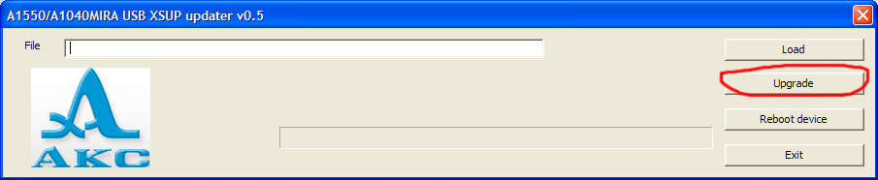

- Finally, move to Option menu and execute Memory cleaning operation.

